_______________________________________________________________________


PUBLISHED AT 2 A.M. MONDAY, JULY 21, 2003

Group formed to move CCO&BB to Los Angeles

LOS ANGELES, CA - Several sources have confirmed that a group has been courting the Chili Cook-Off and Beach Biathlon for a move to Los Angeles. Historically, the annual event has been held in the Pacific Beach area of San Diego. Several sights have been considered for the relocation, including Manhattan Beach and Zuma Beach, or a location to be developed specifically for the event in Inglewood. The group’s cost to allure the CCO&BB away from San Diego, including the creation of a new venue, would be more than offset by the windfall from commercial sponsorship.

The brainchild of San Diego native Jim Bergmark, the CCO&BB was first held in the summer of 1993. While the athletic and culinary competition was fierce from the beginning, the event had little fanfare in its early years. “The spectators were mostly just friends of the participants back then,” said Bergmark. “I would be on the phone for hours begging people to show up.” Of course, all that has changed. One Pacific Beach resident stated, “I plan my vacations around CCO&BB. I used to head out of town in early October to avoid all the traffic and crowds, but now I invite all of my family and friends from back East out and we just enjoy the atmosphere.”

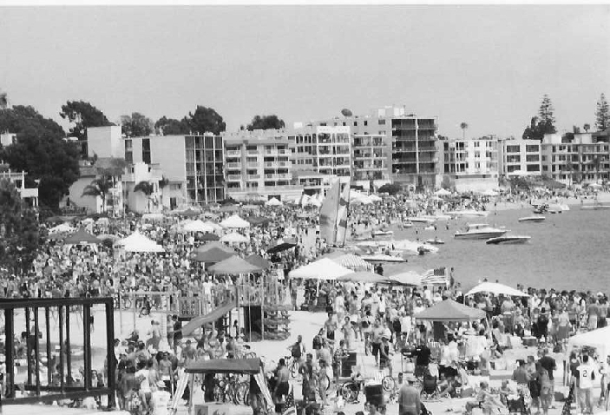
The 10th Annual Chili Cook-Off and Beach Biathlon, pictured here, was held in October 2002 in Pacific Beach, as it has been since its inception in 1993.

When asked about the potential move Bergmark stated “The CCO&BB has always been a privately sponsored event by me and my staff, with little, and I want to emphasize little, financial support from its participants. We prefer that it remain unencumbered by outside interests. The CCO&BB is a San Diego tradition and will stay that way, at least for the immediate future.”

When asked about the possibility of the event’s move, Los Angeles Mayor replied, “San Diego’s reputation has ridden high upon the shoulders of the CCO&BB for ten years now. Holding the event in Los Angeles would give some much needed credibility to our city.” San Diego Mayor stated, “Losing the CCO&BB to Los Angeles would be a blow. If that ever happened I would consider resigning my position and moving to L.A. to stay close to the event.”

The Annual Chili Cook-Off and Beach Biathlon is held on the beach near the Catamaran Hotel in Pacific Beach.

_______________________________________________________________________

